Integrating CPS with Blackboard

Introduction
This document describes the process of integrating grades that have been captured in CPS (eInstruction) with the Blackboard Gradebook.

Understanding the Blackboard Gradebook

The first step is to understand the format of a Blackboard Gradebook entry. This is important since you will need to adjust the format of the CPS Gradebook results before you can import them into Blackboard.

In Blackboard, select Gradebook from the Control Panel, then select:
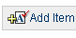

This will allow you to create a “placeholder” test or quiz in Blackboard. Later, you will import the grades from your CPS system into this placeholder.

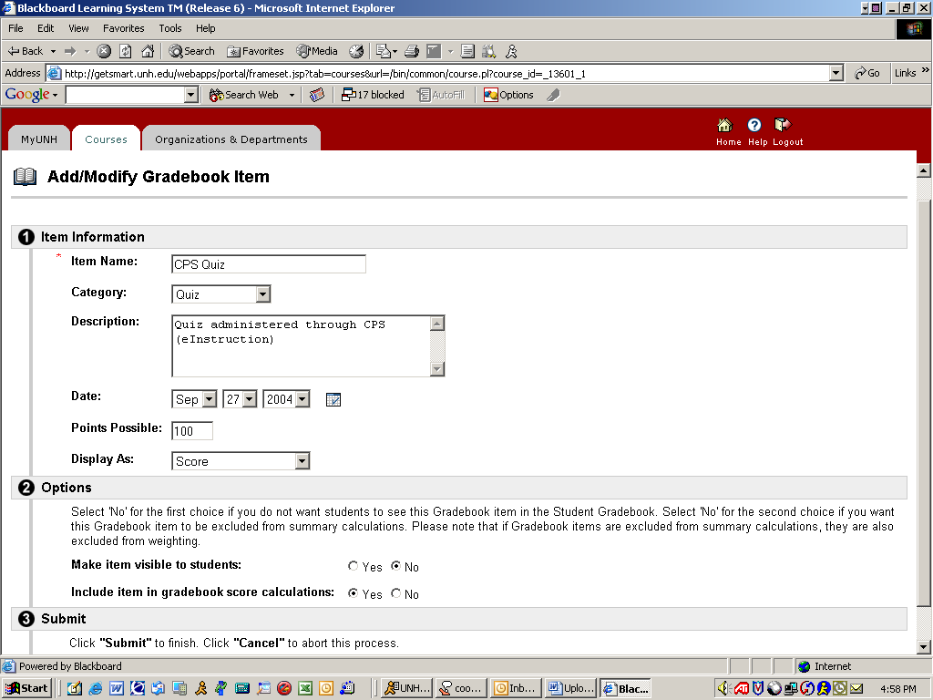

Complete the form as you would any other test or quiz from within Blackboard.
continued on next page
Integrating CPS with Blackboard, continued

Create a sample download file

Next, select Download Grades so that you will have an example of the type of file that Blackboard will expect you to upload. (New 2005: Choose “comma delimited” when asked, and it is better to right click the download button, and choose “save the target as”. Then you get a “gb_export.csv” File.) Later, you will modify this spreadsheet with CPS Gradebook information so that the formatting will adhere to the Blackboard standards when uploading.
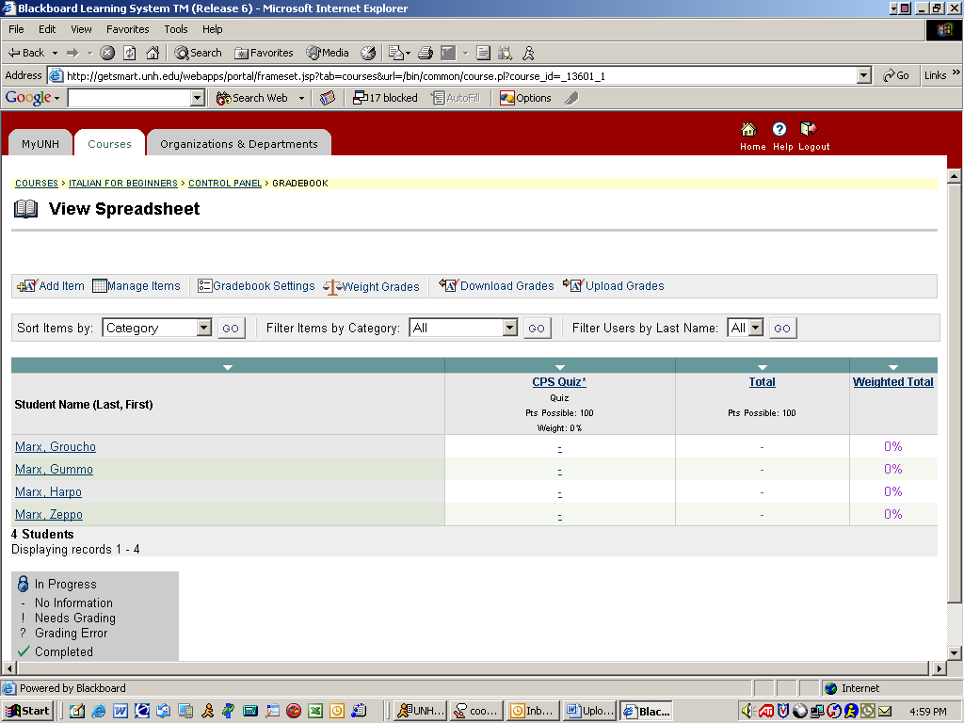

Blackboard Gradebook, continued
After downloading, your Excel spreadsheet should look something like this. Note the headings and pay particular attention to the format of the students’ names.

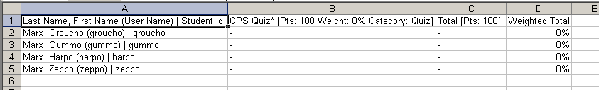

continued on next page
Integrating CPS with Blackboard, continued

Exporting Grades from CPS

Next, use the CPS system as you normally would to create and administer a test or quiz. Remember to select Include in Gradebook when “engaging” the test or quiz in order to capture students’ grades in the CPS Gradebook.

When you are ready to import the grades into Blackboard, select Export from the CPS Gradebook.

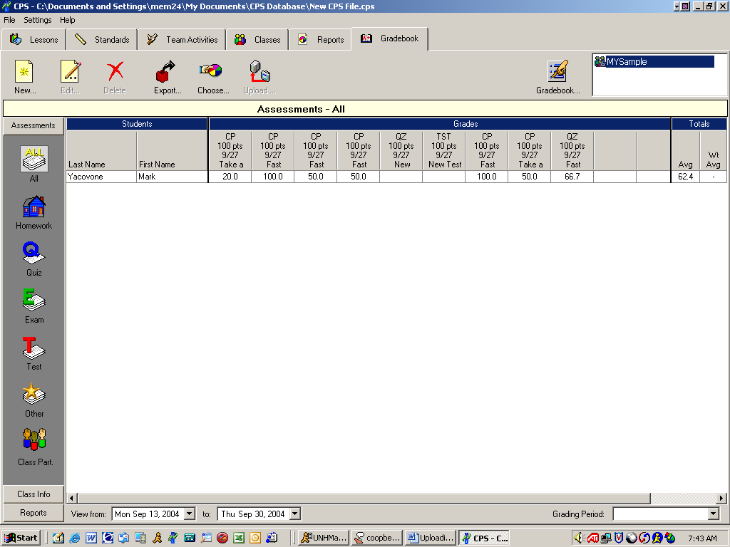

An Excel spreadsheet will be created for you (see below):



Notice that the format is slightly different from the format of a downloaded set of grades in Blackboard.
continued on next page
Integrating CPS with Blackboard, continued

Exporting Grades from CPS, continued

Since the format of the CPS Gradebook cannot be imported into Blackboard “as-is”, you must modify the Excel data you just exported to match the previously “exported” Blackboard Gradebook. It is easiest to edit the Gradebook that you exported earlier from Blackboard by adding the grades you downloaded from the CPS system, rather than trying to adjust the CPS downloaded spreadsheet to “match” the Blackboard spreadsheet.
Important Note: The headings must match the original Blackboard spreadsheet exactly.
The roster ( the name order of the student) should be the same. Some students may have restricted directory information so they show up as a short spelling. I wish there were not so many students do that, because it will cost you extra time to correct the name order.



Once you have modified the spreadsheet to conform to the Blackboard standard, save it on your system as type: CSV (Comma delimited).

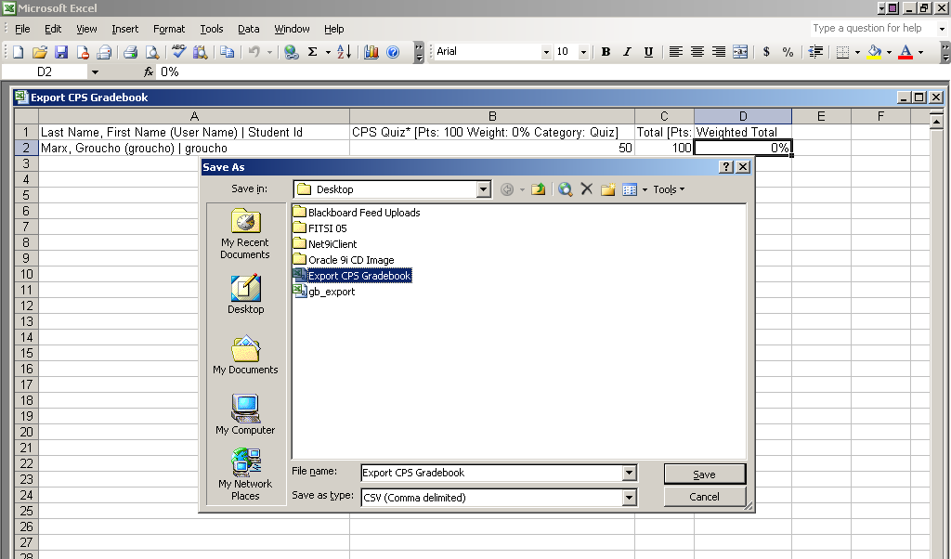
continued on next page
Integrating CPS with Blackboard, continued

Loading Grades into Blackboard

Return to the Blackboard system and select Gradebook from the Control Panel:

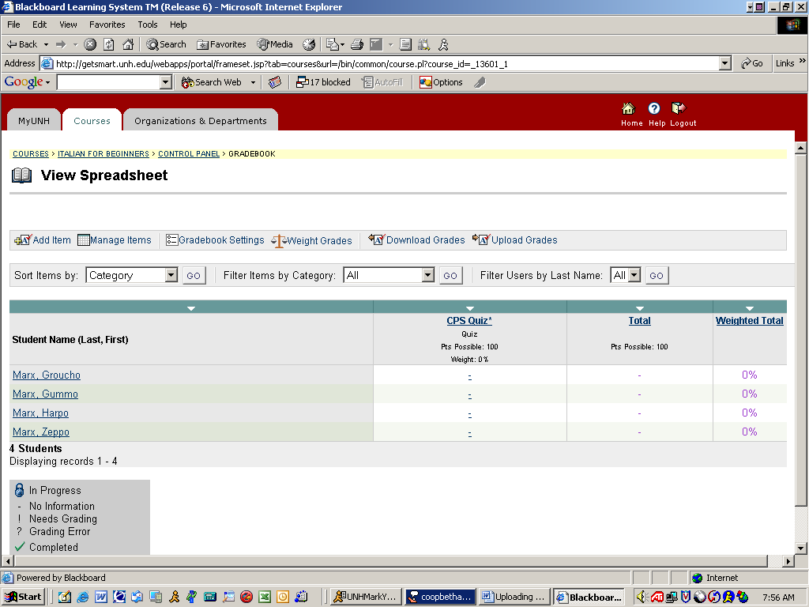

Choose Upload Grades from the menu bar.
continued on next page
Integrating CPS with Blackboard, continued

Uploading Grades
Find and open the modified Excel spreadsheet you created earlier and click Submit:

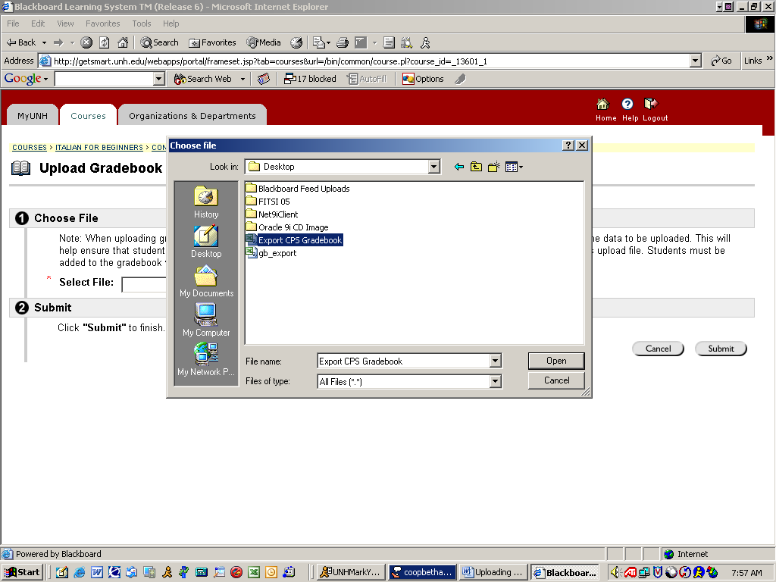
continued on next page
Integrating CPS with Blackboard, continued

Uploading Grades, continued

Select the column you wish to upload, and then select the destination column. If you created a placeholder test or quiz earlier, you should see the name of the test or quiz.

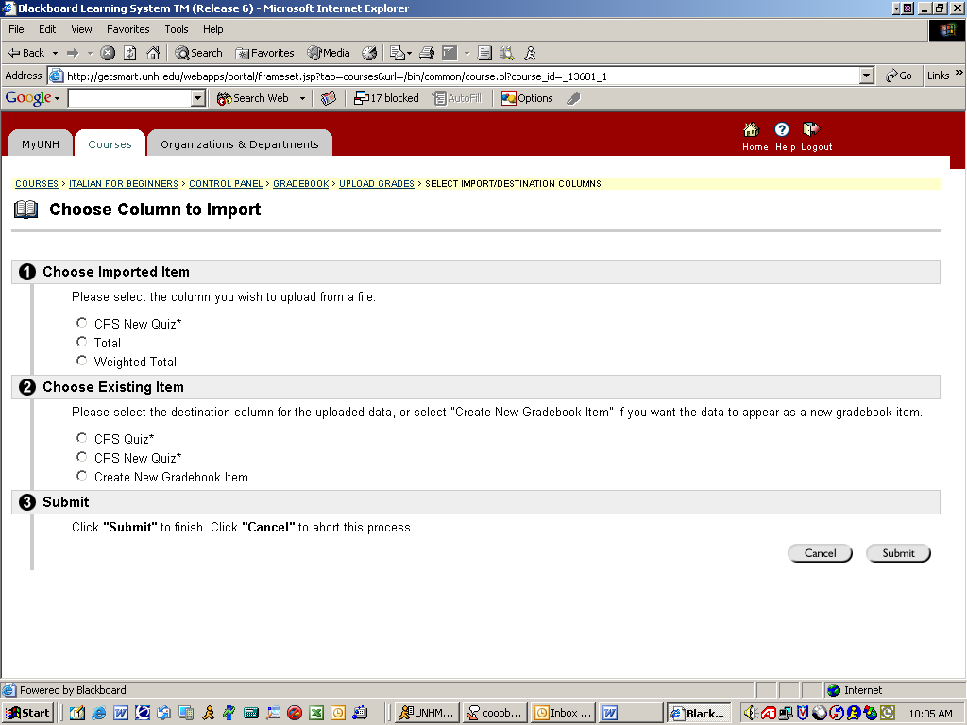

If you have not created a placeholder, you can create the test or quiz at this step. It is recommended that you create a placeholder the first time you try this. Note: Once you understand the format of the Excel spreadsheet you may choose to create the test or quiz at this step without a placeholder.
continued on next page

Integrating CPS with Blackboard, continued

Choose Rows to Import

Next, select the students for whom you wish to upload grades by checking the check boxes next to their name(s). You may choose Select All to select all students enrolled in the course. Then, click Submit.

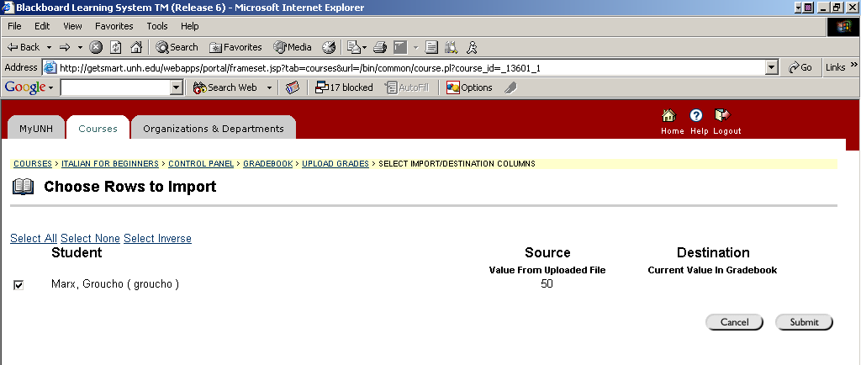

The grade(s) will be added to the Blackboard Gradebook.



